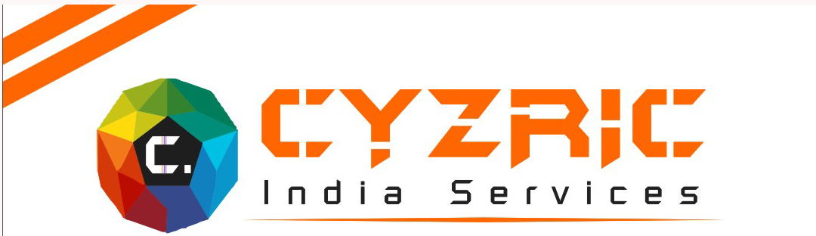

CYZRIC INDIA SERVICES, Internet based Co. established in February 2019 at Greater Faridabad in Haryana. This Company has been promoted by some of highly Experienced-Professionals dedicated to provide Total IT solutions under one roof.

It possesses not only the latest Technology Gadgets but also always ready to support by their all most Knowledgeable and Experiences hands-on as Customize solutions offer from our Client-End at to User Friendly.

We are providing Fully-Professional and CLIENT SATISFIED SERVICES (CSS) such as Website Designing, Graphics Designing, Web Developments and Online Software Developments on Effective & less than popular Cost.

We have been offering the best Web Design Services and building best quality application solutions. Our developments cover all stages of Planning, Strategy and Research, Immense level of Testing & on-time delivery.

“WE ARE PROMPT DELIVER BY NATURE”

We are ready to give the best Support-Service as per client requirement, with quality testing to your business

LIST OF OUR LIVE WEBSITES
Serial No. | Website name | Description
1 | www.cyzric.com | Company Website
2 | www.phmngo.com | Ngo Websites
3 | www.microfalconspl.com | Cargo and Currier company
4 | www.clubvivache.com | Welfare Society non-Government
5 | www.thebdivinerealestate.com | Real estate Company
6 | www.vermahospitalcare.com | Hospital Website
7 | www.countrycargo.co.in | Courier and cargo Company
8 | www.freshico.in | Foods and Beverage Company
9 | www.weddingcarrentaldelhincr.in | Wedding car Purpose
10 | www.geostructial.com | Construction Company
11 | www.btcar.in | Car booking for Rental day wise and Monthly
12 | ww.sscmtransport.in | Transport and Cargo Company in Faridabad
13 | www.sscmtransport.com | Transport Company in Faridabad
14 | www.yashasvielevators.com | Lift maintenance and services
15 | www.thaparconstruction.com | Constructions Company
16 | www.newdlehipublicschool75.com | Public School Website

Our Company Cyzric India Services using Advance Web Technologies

- Web Development And Web Designing
  - PHP/MySQL
  - Code igniter
  - HTML5/Css3
  - Bootstrap
  - Word press
- Database
- MySQL

LIST OF UNDER CONSTRUCTION WEBSITES
Serial No. | Website name | Description
3 | www.perfecta.co.in | Perfecta Accounts Associates
2 | www.greaterfaridabadproperty.in | Real Estate Company
1 | www.pphouse.in | Film Production House

Our
Working Area:

- Website Designing
- Web Developments
- Online Software Developments
- Point of Sale (POS)
- Ecommerce

Our Mission

Cyzric India Services Means to create new dimension of Ideas and Innovation in the Computer Science with the help of latest Technologies. At Cyzric India Services with Technical Proficiency and Expertise, We Cohesively integrates Graphic Design with web Page layout, with interactive Programming with database driven content to Plan build and deploy e- business and to emerge as one of the top IT service Provider.
Our Philosophy

We Cyzric India Services believe in teamwork. With every new day the quest for acquiring new competencies continues. Forever searching, experimenting, innovating, learning, moving ahead with our sincere efforts and dedication, shaping the future, and challenging our competencies to create new opportunities, is a never-ending process in the company.

Cyzric India Services
Office Address: Puri High Street, D-025,
Ground Floor, Sector-81,
Faridabad (Haryana)
Contact Number: 7827237984
Email: contact@cyzric.com
Email ID : cyzricindia@gmail.com
Website: www.cyzric.com

